

**ST. MARY’S SCHOOL SUNDERNAGAR**

**COMPUTER SCIENCE PROJECT**

**2022-23**

**SUBMITTED BY: SUBMITTED TO:**

**NAME:**  MRS.PAYAL JAMWAL

**ROLL NO.**

**CLASS: 12th**

**CERTIFICATE**

This is to certify that a student of class 12th has successfully completed their computer science project on

**“Bank Management System”**

under the guidance of computer science teacher **Mrs. Payal Jamwal.**

**PRINCIPAL**

**EXTERNAL EXAMINER** **INTERNAL EXAMINER**

**ACKNOWLEDGEMENT**

In the accomplishment of this project synopsis successfully, many people have bestowed upon me their blessings and the heart pledge support, this time I am utilizing to thank all the people who have been concerned with this synopsis. Primarily I would like to thank **God** for being able to complete this synopsis with success. Then I would like to thank my Computer Science teacher **Mrs. Payal Jamwal** ma’am whose valuable guidance has been the one that helped me patch this project and make it full proof success, her suggestions and instructions have served as a major contribution towards the completion of this synopsis.

Lastly, I would like to thank **my parents** who have helped me with their valuable suggestions and support which has been very helpful in various phases.

**INDEX**

|  |
| --- |
| * Introduction |
| * About Python |
| * About MySQL |
| * Databases used |
| * Source Code |
| * Outputs |
| * Bibliography |

**Introduction**

A bank transaction is a record of money that has moved in and out of your bank account. Transaction banking plays a role in optimizing working capital in commercial activity by equipping companies with investment options. Transaction banking helps clients to manage their cash inflows and out flows in an effective way and provides them with short term cash management options.

The main types of bank transaction are ATM: deposit or withdraw funds using an ATM and CHECK: withdraw funds by writing a paper check. Banks are essential for managing financial transactions across the country and providing accounts to individual citizens and companies. Each bank manages its own financial system well thanks to high standards for account holders, efficient methods of making money and open business hours. Without banks, financial institutions would be forced to close down due to low profit margins without any way to offset losses in the economy.

Transactions in the banking system are vital for the banking system and economy as a whole. Each bank performs numerous different types of transactions every day, including accepting payments, making loans and keeping records of financial transactions. Additionally, all banks charge fees for transferring funds between accounts- only government workers are exempt from paying fees. Anyone who uses banks will find one that works well for them in easy circumstances, as well as provides excellent customer service should problems occur.

**PYTHON**

**(FRONTEND)**

WHY PYTHON?

* Easy to read, learn and write; it has English like syntax
* Improved productivity
* Interpreted language
* Dynamically typed
* Free and open source
* Vast libraries support, portability

**SQL**

**(BACKEND)**

**WHY SQL?**

* Data security
* On-Demand Scalability
* High Performance
* Round the clock uptime
* Comprehensive transactional support
* Complete workflow control
* Reduced total cost of ownership
* The flexibility of open source

DATABASE AND TABLES:

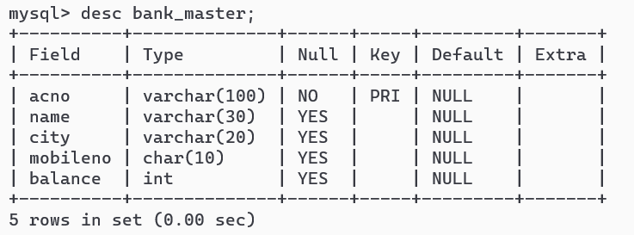

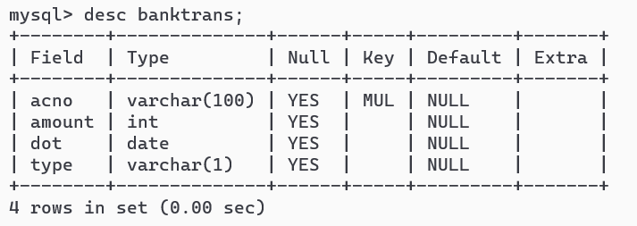

Source Code:

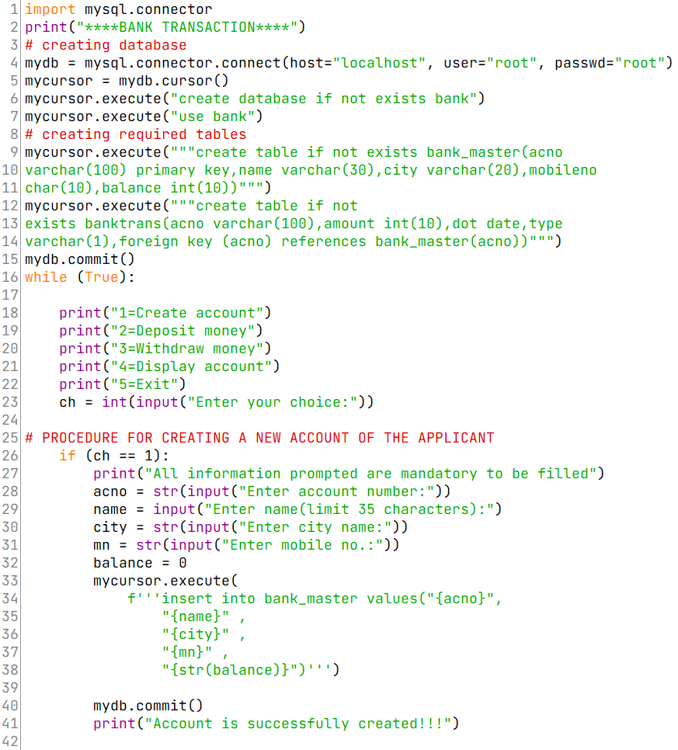

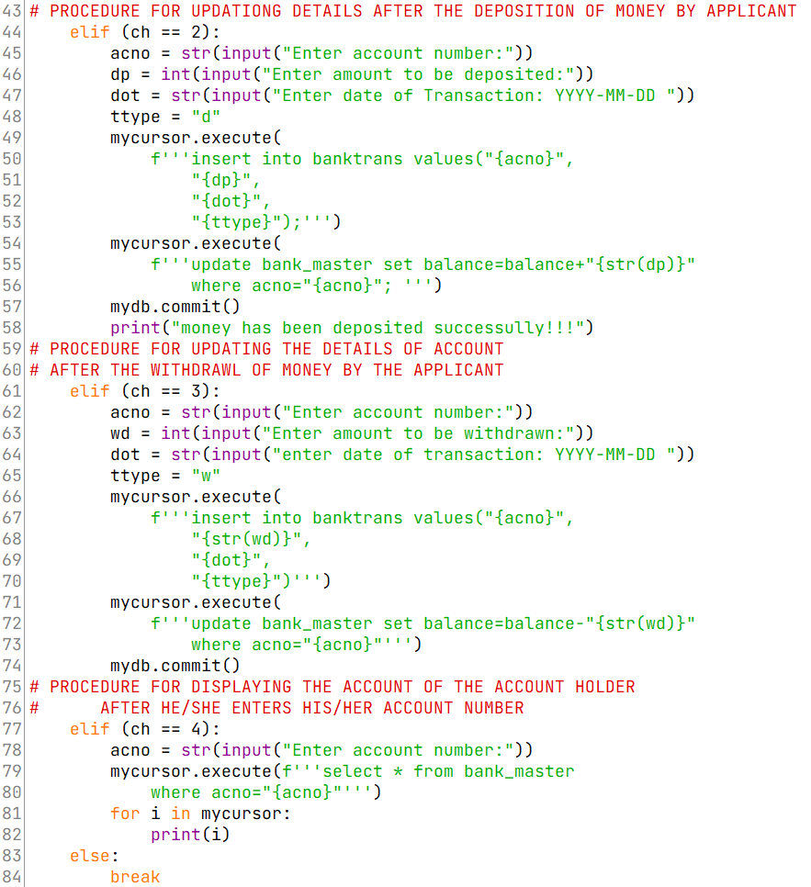

**OUTPUTS**

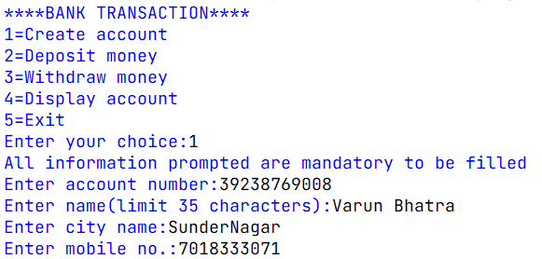

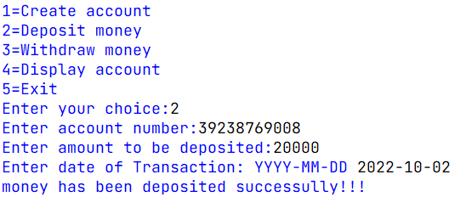

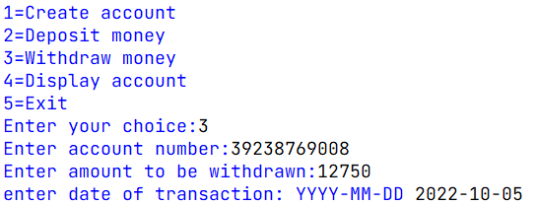

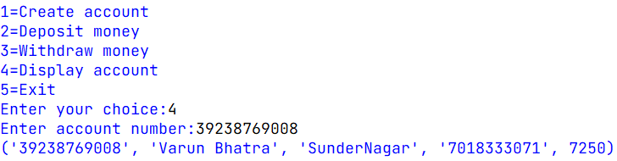

Bank Transaction Table:

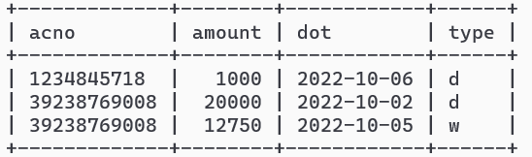

**Bibliography**

* [**www.google.com**](http://www.google.com)
* **stackoverflow.com**
* **www.wikipedia.org**
* **Computer Science with Python Class 12th by Sumita Arora**

**https://www.youtube.com/watch?v=LD24TG33w2E**